Prepare the way of the LORD; make His paths straight.
Every valley shall be exalted and every mountain and hill brought low



St. John’s Lutheran Church &
Valley Bible Academy (K-8)
1107 14th Street, Clarkston, WA
10:15 am Sunday School and Bible Class, 11:00 am Service
www.ClarkstonLutheran.org
Watch the Service at www.ustream.tv
(Search: St. John’s Lutheran Church, Clarkston, WA)
Nursery Room with Service Monitor
Peace Lutheran Church
13946 1st Ave, Orofino, ID
7:30 am Bible Class, 8:00 am Worship Service
orofino.clclutheran.org

Members of the Church of the Lutheran Confession – CLC
Organists: Deena Irby, Donna Lowary, Sue Martin
Pastor Dave Naumann – VBA Teacher Desirae Naumann
1119 14th Street Clarkston, WA 99403
email: pastordavenaumann@gmail.com Cell: 920 266-5384
Church and School: 509 758-8261

2nd Sunday in advent december 4, 2016
Preparation for Worship: Read Psalm 138 (front of the hymnal p. 154)
The Hymns: 136, 701, 704, 391
Prayer: Lord God, heavenly Father, make us diligent in the use of Your Word, and enable us by the grace of Your Holy Spirit to walk before You in fervent faith and all holy obedience, that with constant watchfulness and prayer You will help us prepare our hearts for the second coming of Your Son, Who will take us to live with Him in His eternal Kingdom. In His saving name, Amen.

Opening Prayer
Opening Hymn 136
The Invocation
We invoke (“call upon”) the name of the one true God – Father, Son, and Holy Spirit.
Pastor: In the name of the Father and of the Son and of the Holy Spirit.
Congregation sings:
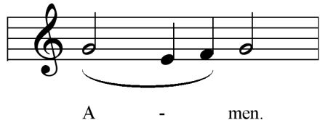

THE CONFESSION AND ABSOLUTION OF SINS
We come before our Holy God recognizing that we are sinful and daily need His forgiveness.
Pastor Beloved in the Lord! Let us draw near with a true heart and confess our sins unto God, our Father, beseeching Him in the name of our Lord Jesus Christ to grant us forgiveness.
Our help is in the name of the Lord.
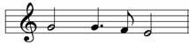
C: Who made heaven and earth.
Pastor I said, I will confess my transgressions unto the Lord.
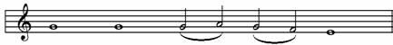
C: And Thou forgavest the iniquity of my sin

Pastor Almighty God, our Maker and Redeemer, we poor sinners confess unto You that we are by nature sinful and unclean and that we have sinned against You by thought, word, and deed. Wherefore we flee for refuge to Your infinite mercy, seeking and imploring Your grace for the sake of our Lord Jesus Christ.
ALL O most merciful God, who has given Your only-begotten Son to die for us, have mercy upon us and for His sake grant us remission of all our sins; and by Your Holy Spirit increase in us true knowledge of You and of Your will and true obedience to Your Word, to the end that by Your grace we may come to everlasting life; through Jesus Christ our Lord. Amen.
Pastor Almighty God, our heavenly Father, has had mercy upon us and has given His only Son to die for us and for His sake forgives us all our sins. To those who believe in His name He gives power to become the sons of God and has promised them His Holy Spirit. He who believes and is baptized shall be saved. Grant this, Lord, unto us all.
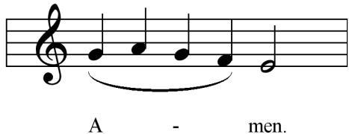 (congregation is seated)
THE INTROIT
Having received the Lord’s forgiveness, we are glad to enter into His courts with praise and thanksgiving. This entrance is made in the Introit with the Lord’s own Word, often from the Psalms.
P: Daughter of Zion:
C: Behold, your Salvation is coming.
P: The Lord shall cause His glorious voice to be heard:
C: And you shall have gladness of heart.
P: Give ear, O Shepherd of Israel:
C: You who lead Joseph like a flock.

THE GLORIA PATRI
Latin for “Glory to the Father”
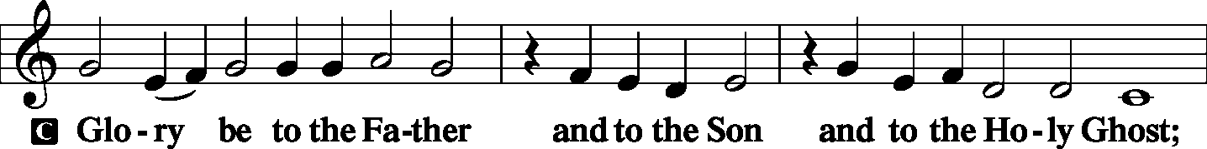
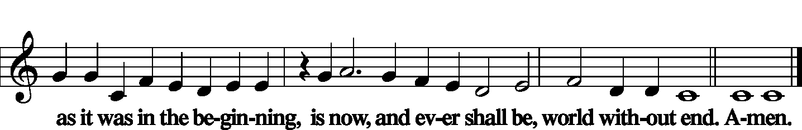
THE KYRIE
Latin for “O Lord.” We approach our Lord with a cry for help in all the needs of our earthly life.
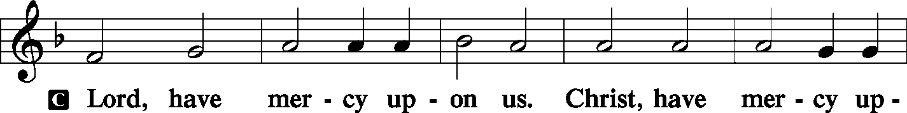
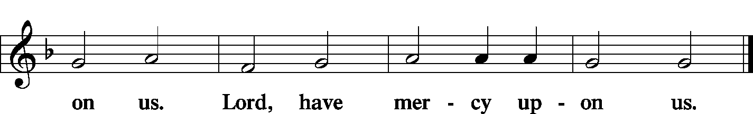
THE GLORIA
A hymn glorifying and praising our God (Hymn 798:1 – all sing)

THE SALUTATION (Greeting)
PASTOR The Lord be with you.
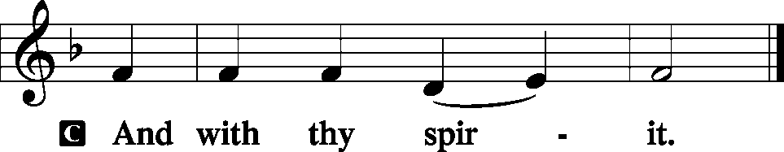
THE COLLECT FOR THE DAY
The main thoughts for the day are “collected” together in this prayer.
PASTOR Let us pray.
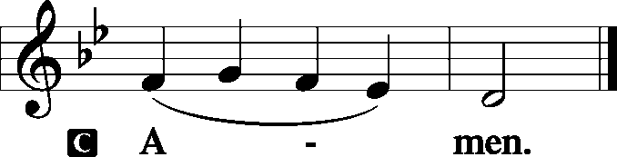

THE BIBLE READINGS
God speaks to us.
The Epistle Reading:
Philippians 1:3-11 I thank my God upon every remembrance of you, 4 always in every prayer of mine making request for you all with joy, 5 for your fellowship in the gospel from the first day until now, 6 being confident of this very thing, that He who has begun a good work in you will complete it until the day of Jesus Christ; 7 just as it is right for me to think this of you all, because I have you in my heart, inasmuch as both in my chains and in the defense and confirmation of the gospel, you all are partakers with me of grace. 8 For God is my witness, how greatly I long for you all with the affection of Jesus Christ. 9 And this I pray, that your love may abound still more and more in knowledge and all discernment, 10 that you may approve the things that are excellent, that you may be sincere and without offense till the day of Christ, 11 being filled with the fruits of righteousness which are by Jesus Christ, to the glory and praise of God.

PASTOR Here ends the Epistle reading. We continue with the responsive reading of:
THE GRADUAL
The Gradual is a “Bridge of praise” that links the Old Testament with the New Testament.
P: Out of Zion, the perfection of beauty, God has shined:
C: Our God shall come.
P: Gather My saints together before Me:
C: Those that have made a covenant with Me by sacrifice. Hallelujah! Hallelujah!
P: The powers of heaven shall be shaken:
C: And then shall they see the Son of Man coming in a cloud with power and
great glory. Hallelujah!

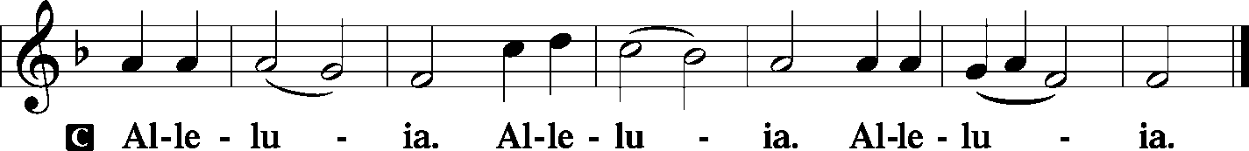

PASTOR The Gospel Reading comes from Luke 3, beginning there in the 1st verse.
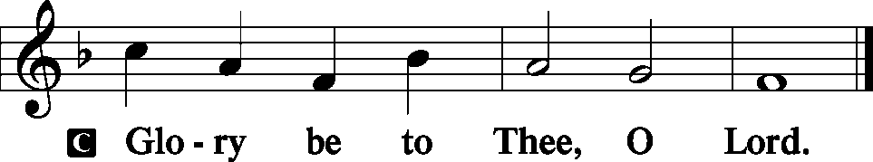

The Gospel Reading
Luke 3:1-6 Now in the fifteenth year of the reign of Tiberius Caesar, Pontius Pilate being governor of Judea, Herod being tetrarch of Galilee, his brother Philip tetrarch of Iturea and the region of Trachonitis, and Lysanias tetrarch of Abilene, 2 while Annas and Caiaphas were high priests, the word of God came to John the son of Zacharias in the wilderness. 3 And he went into all the region around the Jordan, preaching a baptism of repentance for the remission of sins, 4 as it is written in the book of the words of Isaiah the prophet, saying: "The voice of one crying in the wilderness: 'Prepare the way of the LORD; Make His paths straight. 5 Every valley shall be filled And every mountain and hill brought low; The crooked places shall be made straight And the rough ways smooth; 6 And all flesh shall see the salvation of God.'"

PASTOR: Here ends the Gospel Reading.

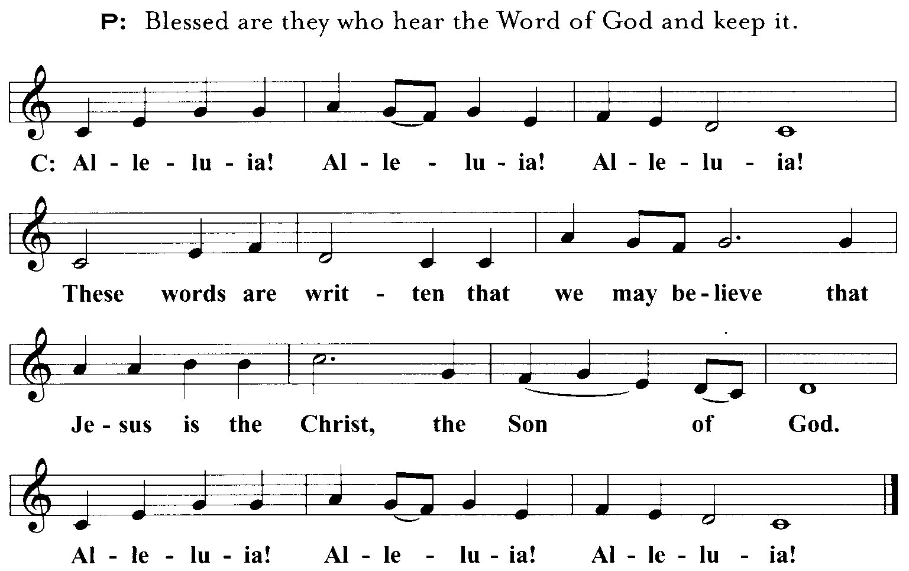
Congregation stands for:
THE APOSTLES’ CREED
We boldly confess what we believe. (Hymnal, page 12)
I believe in God the Father Almighty, Maker of Heaven and earth.
And in Jesus Christ, His only Son, our Lord; Who was conceived by the Holy Ghost, Born of the Virgin Mary; Suffered under Pontius Pilate, Was crucified, dead, and buried; He descended into hell; the third day He rose again from the dead; He ascended into heaven And sitteth on the right hand of God the Father Almighty; From thence He shall come to judge the quick and the dead.
I believe in the Holy Ghost; The Holy Christian Church, the communion of saints; The forgiveness of sins; The resurrection of the body; And the life everlasting. Amen.

Hymn 701

THE SERMON
Malachi 3:1-4 "Behold, I send My messenger, And he will prepare the way before Me. And the Lord, whom you seek, Will suddenly come to His temple, Even the Messenger of the covenant, In whom you delight. Behold, He is coming," Says the LORD of hosts. 2 "But who can endure the day of His coming? And who can stand when He appears? For He is like a refiner's fire And like launderer's soap. 3 He will sit as a refiner and a purifier of silver; He will purify the sons of Levi, And purge them as gold and silver, That they may offer to the LORD An offering in righteousness. 4 "Then the offering of Judah and Jerusalem Will be pleasant to the LORD, As in the days of old, As in former years.
Theme: “A PURE AND BLAMELESS PEOPLE”
I. The Lord’s messenger prepares us for His coming (1)
II. The Lord’s Messenger proclaims repentance (2,3a)
III. The Lord’s Messenger purifies us for priestly service (3b,4)

Sermon Notes

THE OFFERTORY
In this prayer we OFFER God our hearts, asking Him for that best of all gifts, the Holy Spirit.
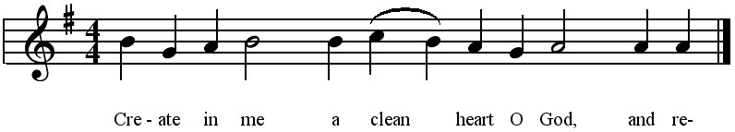
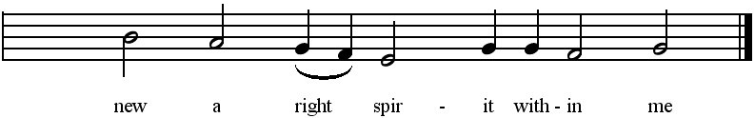
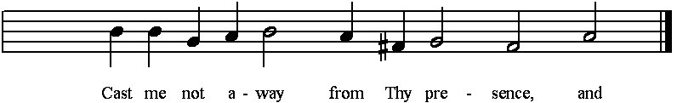
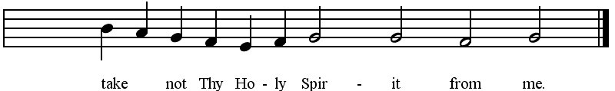
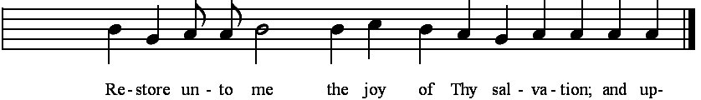
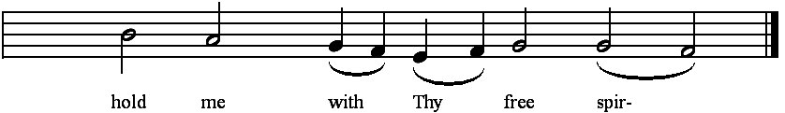

THE OFFERING OF THANKFUL HEARTS
In tangible evidence of our gratitude, we offer the Lord the gift of our money, remembering that He has first given to us that we might have to give to Him. While the ushers present our
offerings at he Lord’s Altar, we stand and sing the offering hymn 127:3:
As they offered gifts most rare At Thy cradle, rude and bare,
So may we with holy joy, Pure and free from sin’s alloy,
All our costliest treasures bring, Christ, to Thee, our heav’nly King!

PRAYERS - (Pastor)

THE LORD’S PRAYER - (All)
Our Father Who art in heaven, hallowed be Thy name. Thy kingdom come. Thy will be done on earth as it is in heaven. Give us this day our daily bread, and forgive us our trespasses as we forgive those who trespass against us. And lead us not into temptation, but deliver us from evil. For Thine is the kingdom and the power and the glory forever and ever, Amen.

Hymn 704

Congregation stands for:
THE BENEDICTION
The blessing given by God for the blessing of His people (Numbers 6:24-26).
PASTOR: The LORD bless you and keep you.
The LORD make His face shine upon you and be gracious unto you.
The LORD lift up His countenance upon you and give you peace.
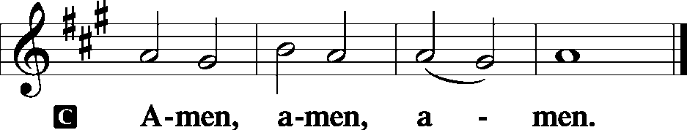

The Closing Hymn 391

*** Silent Prayer ***

A n n o u n c e m e n t s
“If the LORD wills, we will do this or that.” James 4:15

WELCOME EVERYONE! Especially any visitors who may be with us. We are glad you are here and invite you to join us again soon in our worship of the One true God; Father, Son and Holy Spirit. If you are looking for a church home, we hope you’ve found it with us. If you’d like to become a member, we offer a free “Information Course” in which the Pastor will meet with you at your convenience to study and discuss the Bible’s teachings. Just ask!

UPCOMING EVENTS AT PEACE IN OROFINO
Today – church decorating after service
Wednesday – 2nd Midweek Advent Service at 2:00 pm
Sunday Dec. 18 - No morning service. 1:00 pm Christmas Eve service with
potluck following.
CHRISTMAS DAY – 8:00 am service

UPCOMING EVENTS AT ST. JOHN’S IN CLARKSTON
Today – Potluck, church decorating.
Tuesday – Bible Study at 10:30 am
Wednesday – 2nd Midweek Advent Service at 6:30 pm
Saturday – We will participate in the Asotin Lighted Christmas Parade with our school float. Line-up time is 4:15, the parade starts at 5:00 pm.
Sunday Dec. 11 – Ladies Christmas Party following service. A small gift exchange will take place, if you’d like to participate. After that…
Afternoon caroling to the shut-ins. Please consider joining us carolers for an afternoon of singing some favorite Christmas carols to our shut-in members.
Christmas Eve – 5:30 pm service
Christmas Day – 11:00 am service

CHRISTMAS EVE PRACTICE Will be held in place of Sunday School for December 11th and 18th at St. John’s.

Christmas Eve Children’s Goodie Bags There is a box set out in the entry way for donated treats for the bags given to the children on Christmas Eve. Candy, goodies, fruit, etc are welcome! This box will be set out for the next 2 Sundays.

Poinsettias for the Altar You are welcome to bring poinsettias to decorate the front of church, or you may contribute to the Ladies Aid toward their purchase.

MIDWEEK ADVENT SERVICES THIS WEEK The second of three midweek services is scheduled to begin this Wednesday at 2:00 pm at Peace and 6:30 pm at St. John’s. In these services we praise our God for His coming to earth the first time and look forward to His second coming which He has promised is very soon. You are invited! “Grow in the grace and knowledge of our Lord and Savior Jesus Christ. To Him be the glory both now and forever. Amen.” 2 Peter 3:18

CHRISTMAS CARDS Boxes of Christmas cards are still available at St. John’s in the back of the church. The prices are on each box. Payment may be made to “St. John’s Ladies Aid.”

Immanuel Christmas Events: As Christmas approaches, there are a few upcoming Immanuel (ILC in Eau Claire, WI) events. On Sun., Dec. 11, 3 pm, there will be the piano recital at the campus fieldhouse. The highlight of the music department will be the Christmas concert at Messiah Lutheran Church in Eau Claire on Fri., Dec. 16, 7:30 pm. This will include the flute choir, band, mass choir, and tour choir. The choir portion of the event is considered a sacred worship service as the students sing the Christmas Gospel message. This is always a spiritually edifying concert to help one focus, even in the midst of the busy holiday season, on the birth of our Savior, Jesus Christ. This concert ends the busy Finals Week for the students as they conclude their first semester of the academic year with their various tests and projects. We pray the students will safely arrive at their homes in order to enjoy Christmas break with their families. The students resume classes on Jan. 9.

W E E K L Y M E M O R Y V E R S E
"Behold, I send My messenger, And he will prepare the way before Me. And the Lord, whom you seek, Will suddenly come to His temple, Even the Messenger of the covenant, In whom you delight. Behold, He is coming," Says the LORD of hosts. Malachi 3:1-4

The Epistle Reading:
As we prepare for the coming of the Savior, we can’t help but offer thanks for each other and felowship that we share in Jesus. We read.
Philippians 1:3-11 I thank my God upon every remembrance of you, 4 always in every prayer of mine making request for you all with joy, 5 for your fellowship in the gospel from the first day until now, 6 being confident of this very thing, that He who has begun a good work in you will complete it until the day of Jesus Christ; 7 just as it is right for me to think this of you all, because I have you in my heart, inasmuch as both in my chains and in the defense and confirmation of the gospel, you all are partakers with me of grace. 8 For God is my witness, how greatly I long for you all with the affection of Jesus Christ. 9 And this I pray, that your love may abound still more and more in knowledge and all discernment, 10 that you may approve the things that are excellent, that you may be sincere and without offense till the day of Christ, 11 being filled with the fruits of righteousness which are by Jesus Christ, to the glory and praise of God.

THE GRADUAL
P: Out of Zion, the perfection of beauty, God has shined:
C: Our God shall come.
P: Gather My saints together before Me:
C: Those that have made a covenant with Me by sacrifice. Hallelujah! Hallelujah!
P: The powers of heaven shall be shaken:
C: And then shall they see the Son of Man coming in a cloud with power and
great glory. Hallelujah!

The Gospel Reading
Here Luke tells us the mission of John the baptist: to preach the law and gospel. Bring down the high and mighty and lift up the lowly. What a great reminder for us believers as we prepare our hearts for our Savior’s coming. We read…
Luke 3:1-6 Now in the fifteenth year of the reign of Tiberius Caesar, Pontius Pilate being governor of Judea, Herod being tetrarch of Galilee, his brother Philip tetrarch of Iturea and the region of Trachonitis, and Lysanias tetrarch of Abilene, 2 while Annas and Caiaphas were high priests, the word of God came to John the son of Zacharias in the wilderness. 3 And he went into all the region around the Jordan, preaching a baptism of repentance for the remission of sins, 4 as it is written in the book of the words of Isaiah the prophet, saying: "The voice of one crying in the wilderness: 'Prepare the way of the LORD; Make His paths straight. 5 Every valley shall be filled And every mountain and hill brought low; The crooked places shall be made straight And the rough ways smooth; 6 And all flesh shall see the salvation of God.'"
PASTOR: Here ends the Gospel Reading.

