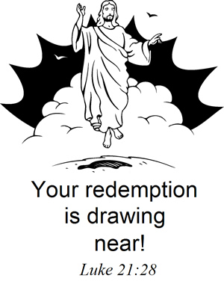

St. John’s Lutheran Church &
Valley Bible Academy (K-8)
1107 14th Street, Clarkston, WA
10:15 am Sunday School and Bible Class, 11:00 am Service
www.ClarkstonLutheran.org
Watch the Service at www.ustream.tv
(Search: St. John’s Lutheran Church, Clarkston, WA)
Nursery Room with Service Monitor
Peace Lutheran Church
13946 1st Ave, Orofino, ID
7:30 am Bible Class, 8:00 am Worship Service
orofino.clclutheran.org

Members of the Church of the Lutheran Confession – CLC
Organists: Deena Irby, Donna Lowary, Sue Martin
Pastor Dave Naumann – VBA Teacher Desirae Naumann
1119 14th Street Clarkston, WA 99403
email: pastordavenaumann@gmail.com Cell: 920 266-5384
Church and School: 509 758-8261

1st Sunday in advent November 27, 2016
Preparation for Worship: Read Psalm 85 (front of the hymnal p. 140)
The Hymns: 55, 702, 645, 87
Prayer: O Lord Jesus Christ, as we celebrate Your advent on this first Sunday of the church year send Your Holy Spirit to open our hearts. Come with Your blessing upon our congregation, giving faithfulness to our pastor and teachers and success to their efforts, bestowing upon all our members brotherly love for one another and a zeal to spread the Gospel. Finally, come Lord Jesus! Amen.

Opening Prayer
Opening Hymn 55
The Invocation
We invoke (“call upon”) the name of the one true God – Father, Son, and Holy Spirit.
Pastor: In the name of the Father and of the Son and of the Holy Spirit.
Congregation sings:
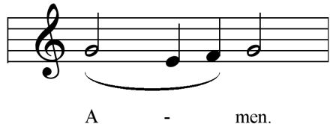

THE CONFESSION AND ABSOLUTION OF SINS
We come before our Holy God recognizing that we are sinful and daily need His forgiveness.
Pastor Beloved in the Lord! Let us draw near with a true heart and confess our sins unto God, our Father, beseeching Him in the name of our Lord Jesus Christ to grant us forgiveness.
Our help is in the name of the Lord.
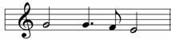
C: Who made heaven and earth.

Pastor I said, I will confess my transgressions unto the Lord.
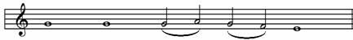
C: And Thou forgavest the iniquity of my sin

Pastor Almighty God, our Maker and Redeemer, we poor sinners confess unto You that we are by nature sinful and unclean and that we have sinned against You by thought, word, and deed. Wherefore we flee for refuge to Your infinite mercy, seeking and imploring Your grace for the sake of our Lord Jesus Christ.
ALL O most merciful God, who hast given Thine only-begotten Son to die for us, have mercy upon us and for His sake grant us remission of all our sins; and by Thy Holy Spirit increase in us true knowledge of Thee and of Thy will and true obedience to Thy Word, to the end that by Thy grace we may come to everlasting life; through Jesus Christ our Lord. Amen.

Pastor Almighty God, our heavenly Father, has had mercy upon us and has given His only Son to die for us and for His sake forgives us all our sins. To those who believe in His name He gives power to become the sons of God and has promised them His Holy Spirit. He who believes and is baptized shall be saved. Grant this, Lord, unto us all.
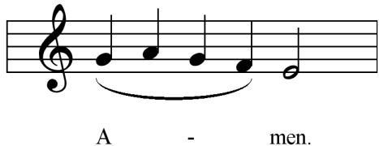 (congregation is seated)

THE INTROIT
Having received the Lord’s forgiveness, we are glad to enter into His courts with praise and thanksgiving. This entrance is made in the Introit with the Lord’s own Word, often from the Psalms.
P: Unto You, O Lord, do I lift up my soul:
C: O my God, I trust in You.
P: Do not let me be ashamed:
C: Do not let my enemies overcome me.
P: Let no one who looks to you for help:
C: Ever be ashamed.
P: Show me Your ways, O Lord:
C: Teach me to follow in Your paths.

THE GLORIA PATRI
Latin for “Glory to the Father”
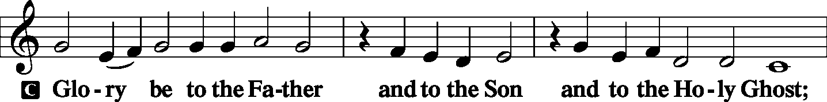
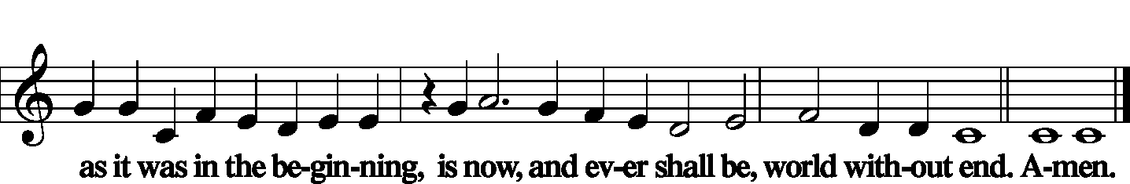

THE KYRIE
Latin for “O Lord.” We approach our Lord with a cry for help in all the needs of our earthly life.
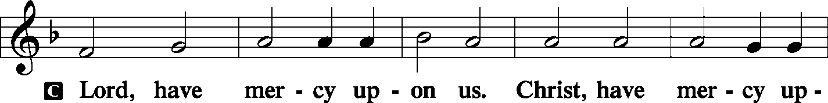
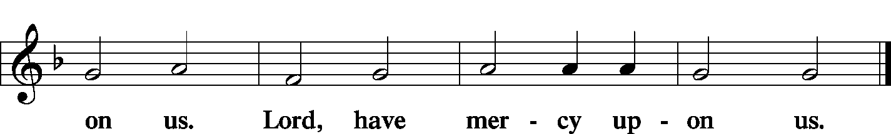

THE GLORIA
A hymn glorifying and praising our God (Hymn 798:1 – all sing)

THE SALUTATION (Greeting)
PASTOR The Lord be with you.
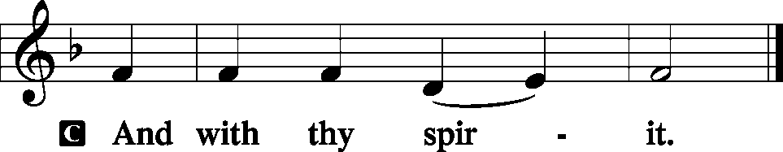

THE COLLECT FOR THE DAY
The main thoughts for the day are “collected” together in this prayer.
PASTOR Let us pray.
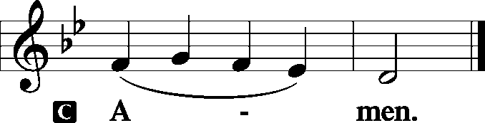

THE BIBLE READINGS
God speaks to us.
The Epistle Reading:
1 Thessalonians 3:9-13 For what thanks can we render to God for you, for all the joy with which we rejoice for your sake before our God, 10 night and day praying exceedingly that we may see your face and perfect what is lacking in your faith? 11 Now may our God and Father Himself, and our Lord Jesus Christ, direct our way to you. 12 And may the Lord make you increase and abound in love to one another and to all, just as we do to you, 13 so that He may establish your hearts blameless in holiness before our God and Father at the coming of our Lord Jesus Christ with all His saints.
PASTOR Here ends the Epistle Reading. We continue with the
responsive reading of:
THE GRADUAL
The Gradual is a “Bridge of praise” that links the Old Testament with the New Testament.
P: All those who look to You for help:
C: These shall never be ashamed, O Lord.
P: Show me Your ways, O Lord:
C: Teach me Your paths. Hallelujah! Hallelujah!
P: Show us Your mercy, O Lord:
C: And grant to us Your salvation. Hallelujah!

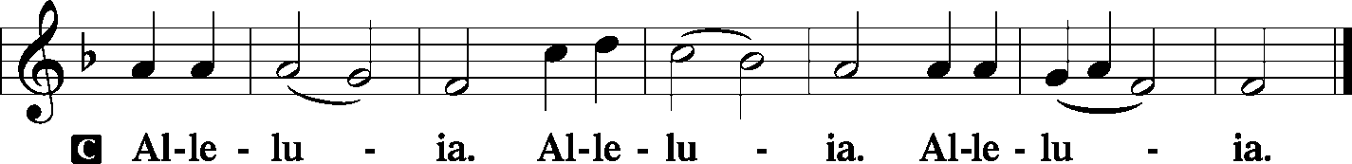

PASTOR The Gospel Reading comes from Luke chapter 21, beginning there in the 25th verse.
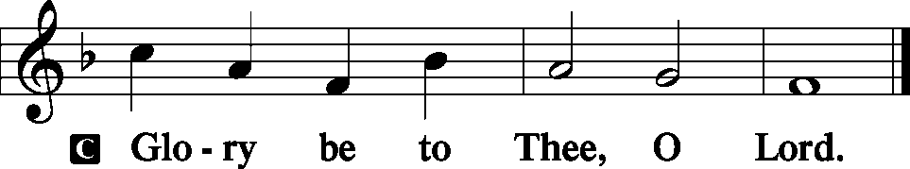

The Gospel Reading
Luke 21:25-36 "And there will be signs in the sun, in the moon, and in the stars; and on the earth distress of nations, with perplexity, the sea and the waves roaring; 26 "men's hearts failing them from fear and the expectation of those things which are coming on the earth, for the powers of heaven will be shaken. 27 "Then they will see the Son of Man coming in a cloud with power and great glory. 28 "Now when these things begin to happen, look up and lift up your heads, because your redemption draws near." 29 Then He spoke to them a parable: "Look at the fig tree, and all the trees. 30 "When they are already budding, you see and know for yourselves that summer is now near. 31 "So you also, when you see these things happening, know that the kingdom of God is near. 32 "Assuredly, I say to you, this generation will by no means pass away till all things take place. 33 "Heaven and earth will pass away, but My words will by no means pass away. 34 "But take heed to yourselves, lest your hearts be weighed down with carousing, drunkenness, and cares of this life, and that Day come on you unexpectedly. 35 "For it will come as a snare on all those who dwell on the face of the whole earth. 36 "Watch therefore, and pray always that you may be counted worthy to escape all these things that will come to pass, and to stand before the Son of Man."

PASTOR: Here ends the Gospel Reading.
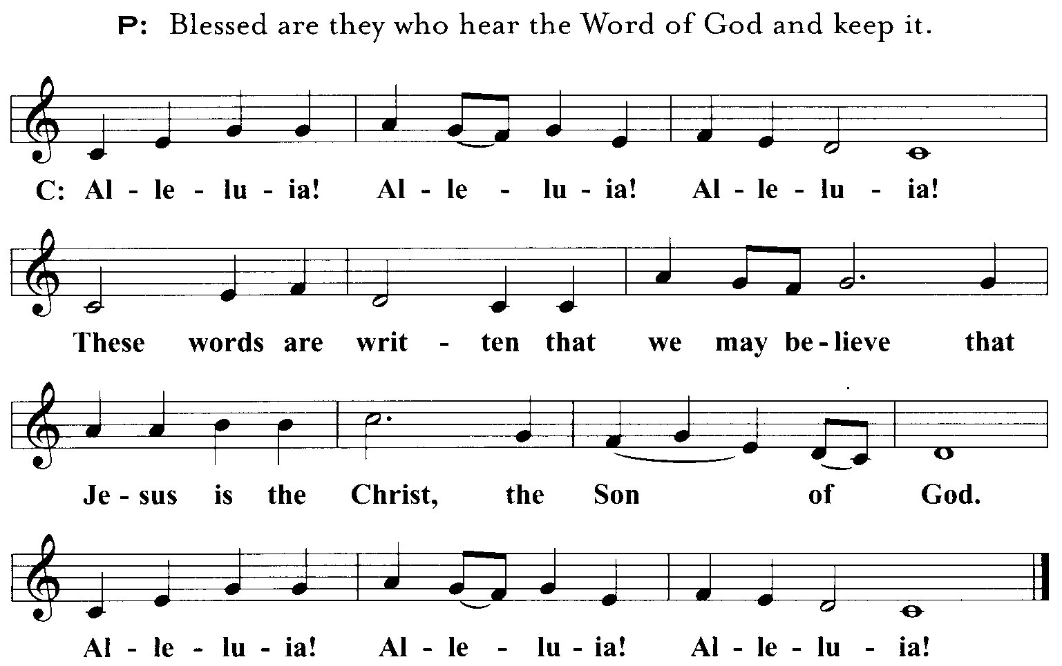

Congregation stands for:
THE APOSTLES’ CREED
We boldly confess what we believe. (Hymnal, page 12)
I believe in God the Father Almighty, Maker of Heaven and earth.
And in Jesus Christ, His only Son, our Lord; Who was conceived by the Holy Ghost, Born of the Virgin Mary; Suffered under Pontius Pilate, Was crucified, dead, and buried; He descended into hell; the third day He rose again from the dead; He ascended into heaven And sitteth on the right hand of God the Father Almighty; From thence He shall come to judge the quick and the dead.
I believe in the Holy Ghost; The Holy Christian Church, the communion of saints; The forgiveness of sins; The resurrection of the body; And the life everlasting. Amen.

Congregation sings Hymn 702

THE SERMON
Jeremiah 33:14-16 'Behold, the days are coming,' says the LORD, 'that I will perform that good thing which I have promised to the house of Israel and to the house of Judah: 15 'In those days and at that time I will cause to grow up to David A Branch of righteousness; He shall execute judgment and righteousness in the earth. 16 In those days Judah will be saved, And Jerusalem will dwell safely. And this is the name by which she will be called: THE LORD OUR RIGHTEOUSNESS.'
Theme: “A NAME TO REMEMBER”
I: Promised of old (14)
II: Granted in time (15)
III: Ours for eternity (16)

THE OFFERTORY
In this prayer we OFFER God our hearts, asking Him for that best of all gifts, the Holy Spirit.
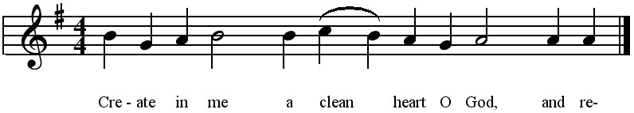
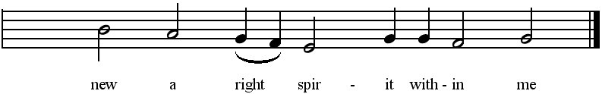
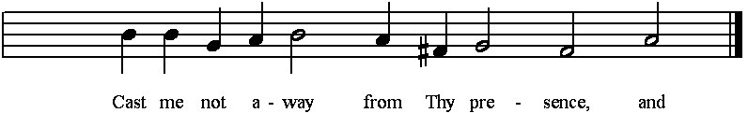
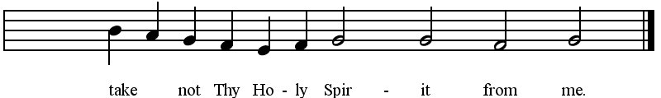
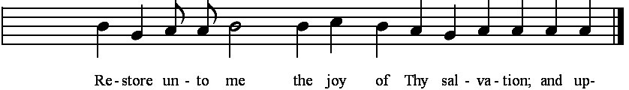
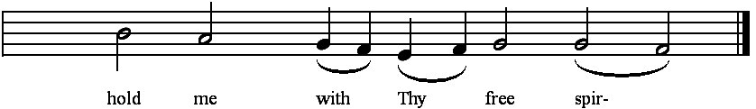


THE OFFERING OF THANKFUL HEARTS
In tangible evidence of our gratitude, we offer the Lord the gift of our money, remembering that He has first given to us that we might have to give to Him. While the ushers present our
offerings at he Lord’s Altar, we stand and sing the offering hymn 127:3:
As they offered gifts most rare At Thy cradle, rude and bare,
So may we with holy joy, Pure and free from sin’s alloy,
All our costliest treasures bring, Christ, to Thee, our heav’nly King!

PRAYERS - (Pastor)
THE LORD’S PRAYER - (All)
Our Father Who art in heaven, hallowed be Thy name. Thy kingdom come. Thy will be done on earth as it is in heaven. Give us this day our daily bread, and forgive us our trespasses as we forgive those who trespass against us. And lead us not into temptation, but deliver us from evil. For Thine is the kingdom and the power and the glory forever and ever, Amen.

Congregation sings Hymn 645
Congregation stands for:
THE BENEDICTION
The blessing given by God for the blessing of His people (Numbers 6:24-26).
PASTOR: The LORD bless you and keep you.
The LORD make His face shine upon you and be gracious unto you.
The LORD lift up His countenance upon you and give you peace.
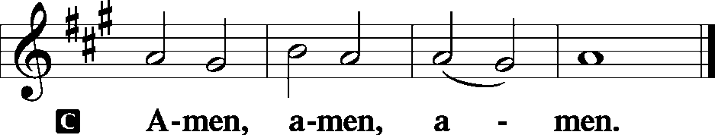

The Closing Hymn 87
A n n o u n c e m e n t s
“If the LORD wills, we will do this or that.” James 4:15

WELCOME EVERYONE! Especially any visitors who may be with us. We are glad you are here and invite you to join us again soon in our worship of the One true God; Father, Son and Holy Spirit. If you are looking for a church home, we hope you’ve found it with us. If you’d like to become a member, we offer a free “Information Course” in which the Pastor will meet with you at your convenience to study and discuss the Bible’s teachings. Just ask!

UPCOMING EVENTS AT PEACE IN OROFINO
Wednesday – 1st Midweek Advent Service at 2:00 pm
Sunday Dec. 11 – Church decorating following service
Sunday Dec. 18 - No morning service. 1:00 pm Christmas Eve service with potluck following.
CHRISTMAS DAY – 8:00 am service

UPCOMING EVENTS AT ST. JOHN’S IN CLARKSTON
Today – We are putting the finishing touches on our float for the Clarkston Lighted Christmas Parade which is this Saturday at beginning at 4:30pm. Anyone helping with this activity may stay after church for cup of white chicken chile. We are also planning to have the same float for the Asotin Lighted Christmas Parade on Saturday, December 10th at 5:00pm.
Tuesday – Bible Study at 10:30 am
Wednesday – 1st Midweek Advent Service at 6:30 pm
Next Sunday Dec. 4 – Potluck, church decorating.
Sunday Dec. 11 – Ladies Christmas Party following service. A small gift exchange will take place, if you’d like to participate. After that…
Afternoon caroling to the shut-ins. Please consider joining us carolers for an afternoon of singing some favorite Christmas carols to our shut-in members.
Christmas Eve – 5:30 pm service
Christmas Day – 11:00 am service

CHRISTMAS EVE PRACTICE Will be held in place of Sunday School for December 11th and 18th at St. John’s.

Christmas Eve Children’s Goodie Bags There will be a box set out in the fellowship hall for items for the bags given to the children on Christmas Eve. Candy, goodies, fruit, etc are welcome! This box will be set out for the next 3 Sundays.

Poinsettias for the Altar You are welcome to bring poinsettias to decorate the front of church, or you may contribute to the Ladies Aid toward their purchase.

MIDWEEK ADVENT SERVICES THIS WEEK The first of three midweek services is scheduled to begin this Wednesday at 2:00 pm at Peace and 6:30 pm at St. John’s. In these services we praise our God for His coming to earth the first time and look forward to His second coming which He has promised is very soon. You are invited! “Grow in the grace and knowledge of our Lord and Savior Jesus Christ. To Him be the glory both now and forever. Amen.” 2 Peter 3:18

CHRISTMAS CARDS Boxes of Christmas cards are still available at St. John’s in the back of the church. The prices are on each box. Payment may be made to “St. John’s Ladies Aid.”

CLC Missionary Call - In a September call meeting of the Board of Missions chaired by our CLC President, Michael Eichstadt, a call was issued to Pastor Todd Ohlmann to become our CLC Visiting Missionary. After six weeks of prayerful deliberation, Pastor Ohlmann accepted that call. For this we give praise and thanks to the Lord of the harvest. Pastor Ohlmann will begin his service as CLC Missionary on January 1, 2017. We invite members of CLC congregations to attend a Commissioning service for Missionary Ohlmann at Messiah Lutheran Church in Eau Claire, Wisconsin on Monday, January 2, 2017 at 7:00pm. As presented to our CLC Convention this summer, this call is unlike previous CLC Missionary calls. Missionary Ohlmann will be stationed here in the United States (the Ohlmann's plan to remain in the St. Louis area), but will spend approximately 6 months each year making regular visitations to our sister church bodies and developing contacts in foreign fields. In the months that he is stateside his duties will include visits to domestic subsidized congregations, correspondence with foreign affiliates and new contacts, continuing development of the Online Theological Studies website, assisting with the CLC Mission Helper Program, attending Board of Missions meetings in an advisory capacity, guest preaching, attending area delegate conferences, and any other opportunities the Board of Missions deems appropriate and necessary. The Board of Missions will be holding a special meeting on January 2-3, and working through Pastor Ohlmann's transition as chairman of the Board of Missions to serving the Board in an advisory capacity.

CLC NEWS <> The Rev. Timothy Wheaton, pastor of Living Word Lutheran, Blue Springs MO, has returned the call to Rock of Ages Lutheran, Grand Rapids MI.

W E E K L Y M E M O R Y V E R S E
In His days Judah will be saved, And Israel will dwell safely; Now this is His name by which He will be called: THE LORD OUR RIGHTEOUSNESS.
Jeremiah 23:6
The Epistle Reading:
This Advent season, we thank God for giving us faith to believe in the coming our Savior Jesus. His appearing at the 1st Christmas as well as His second appearance. May our great God cause us to grow in love this season to one another and to all! We read…
1 Thessalonians 3:9-13 For what thanks can we render to God for you, for all the joy with which we rejoice for your sake before our God, 10 night and day praying exceedingly that we may see your face and perfect what is lacking in your faith? 11 Now may our God and Father Himself, and our Lord Jesus Christ, direct our way to you. 12 And may the Lord make you increase and abound in love to one another and to all, just as we do to you, 13 so that He may establish your hearts blameless in holiness before our God and Father at the coming of our Lord Jesus Christ with all His saints.

THE GRADUAL
P: All those who look to You for help:
C: These shall never be ashamed, O Lord.
P: Show me Your ways, O Lord:
C: Teach me Your paths. Hallelujah! Hallelujah!
P: Show us Your mercy, O Lord:
C: And grant to us Your salvation. Hallelujah!

The Gospel Reading
The Christian Church on earth is a waiting Church. We are waiting to celebrate Christmas! Here we have Jesus’ certain and sure promise that He will come again with power and great glory. We read…
Luke 21:25-36 "And there will be signs in the sun, in the moon, and in the stars; and on the earth distress of nations, with perplexity, the sea and the waves roaring; 26 "men's hearts failing them from fear and the expectation of those things which are coming on the earth, for the powers of heaven will be shaken. 27 "Then they will see the Son of Man coming in a cloud with power and great glory. 28 "Now when these things begin to happen, look up and lift up your heads, because your redemption draws near." 29 Then He spoke to them a parable: "Look at the fig tree, and all the trees. 30 "When they are already budding, you see and know for yourselves that summer is now near. 31 "So you also, when you see these things happening, know that the kingdom of God is near. 32 "Assuredly, I say to you, this generation will by no means pass away till all things take place. 33 "Heaven and earth will pass away, but My words will by no means pass away. 34 "But take heed to yourselves, lest your hearts be weighed down with carousing, drunkenness, and cares of this life, and that Day come on you unexpectedly. 35 "For it will come as a snare on all those who dwell on the face of the whole earth. 36 "Watch therefore, and pray always that you may be counted worthy to escape all these things that will come to pass, and to stand before the Son of Man."

PASTOR: Here ends the Gospel Reading.

