The Strange Labor Laws of God’s Vineyard

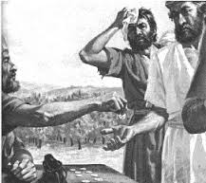

St. John’s Ev. Lutheran Church of Clarkston WA &
Valley Bible Academy
1107 14th Street
10:30 am Summer Worship Service
www.ClarkstonLutheran.org
Watch the Service at www.ustream.tv
(Search: St. John’s Lutheran Church, Clarkston, WA)
Nursery Room with Service Monitor

Peace Lutheran Church of Orofino ID
13946 1st Ave
8:00 am Summer Worship Service
orofino.clclutheran.org

Members of the Church of the Lutheran Confession – CLC

Organists: Deena Irby, Donna Lowary, Sue Martin
Pastor Dave Naumann Teacher Desirae Naumann
email: pastordavenaumann@gmail.com
Church: 509 758-8261 Cell: 920 266-5384

18th sunday AFTER pENTECOST September 18, 2016
Preparation for Worship: Read Psalm 103 (front of the hymnal p. 145)
The Hymns: 39, 492, 307, 46
Prayer: O God the Holy Spirit, You Who are one with the Father and the Son, we thank You that You have begun in us Your work of sanctification in our lives. Cause our faith to increase, and move us to good works by Gospel filled hearts. Clothed in our Savior's righteousness, see us safely through to eternal life. In Jesus name Amen.

Opening Prayer
Opening Hymn 39

The Invocation
We invoke (“call upon”) the name of the one true God – Father, Son, and Holy Spirit.
Pastor: In the name of the Father and of the Son and of the Holy Spirit.
Congregation sings:
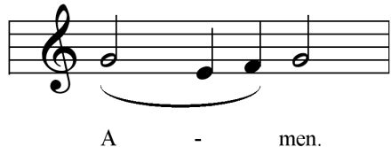

THE CONFESSION AND ABSOLUTION OF SINS
We come before our Holy God recognizing that we are sinful and daily need His forgiveness.
Pastor Beloved in the Lord! Let us draw near with a true heart and confess our sins unto God, our Father, beseeching Him in the name of our Lord Jesus Christ to grant us forgiveness.
Our help is in the name of the Lord.
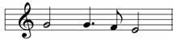
C: Who made heaven and earth.
Pastor I said, I will confess my transgressions unto the Lord.
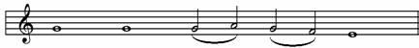
C: And Thou forgavest the iniquity of my sin

ALL: O almighty God, merciful Father, I, a poor, miserable sinner, confess unto You all my sins and iniquities with which I have ever offended You and justly deserved Your temporal and eternal punishment. But I am heartily sorry for them and sincerely repent of them, and I pray You of Your boundless mercy and for the sake of the holy, innocent, bitter sufferings and death of Your beloved Son, Jesus Christ, to be gracious and merciful to me, a poor, sinful being.

PASTOR: Upon this your confession, I, by virtue of my office as a called servant of God’s Word, announce the grace of God unto all of you, and in the stead and by the command of our Lord Jesus Christ; I forgive you all your sins in the name of the Father and of the Son and of the Holy Ghost.

C 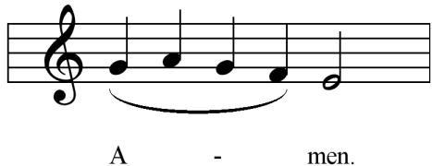 (congregation is seated)

THE INTROIT
Having received the Lord’s forgiveness, we are glad to enter into His courts with praise and thanksgiving. This entrance is made in the Introit with the Lord’s own Word, often from the Psalms.
P: Righteous are You, O Lord:
C: And upright are Your judgments.
P: Deal with Your servant:
C: According to Your mercy.
P: Blessed are the undefiled in the way:
C: Who walk in the way of the Lord.

THE GLORIA PATRI
Latin for “Glory to the Father”
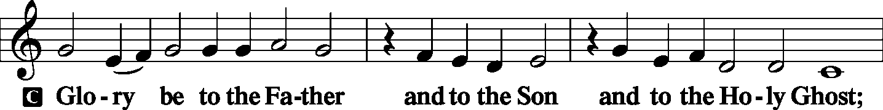
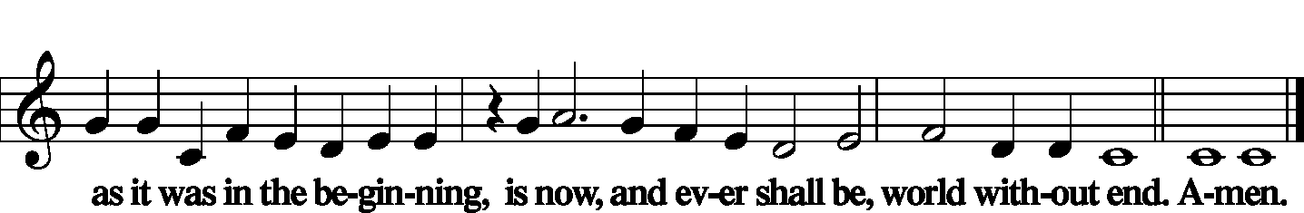

THE KYRIE
Latin for “O Lord.” We approach our Lord with a cry for help in all the needs of our earthly life.
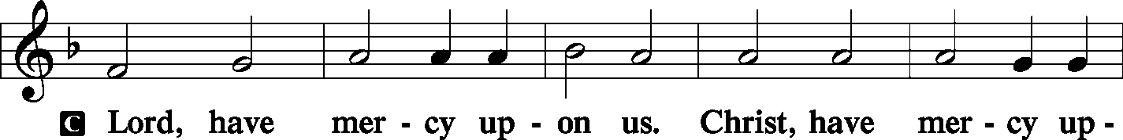
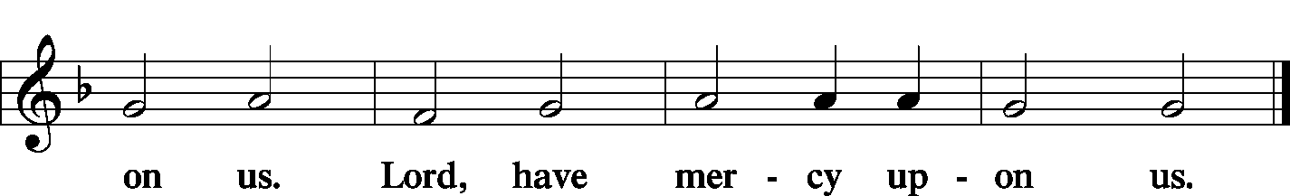
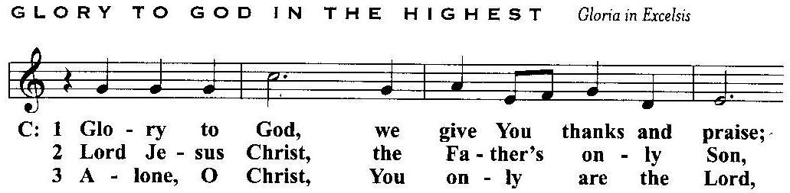
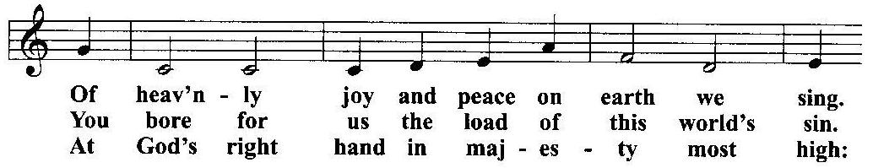
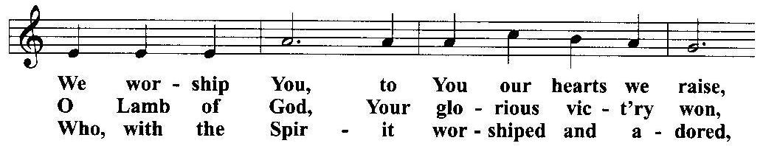
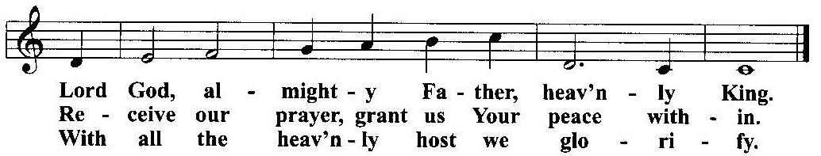

THE SALUTATION (Greeting)
PASTOR The Lord be with you.

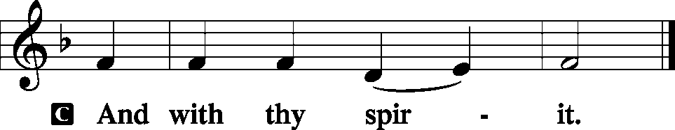

THE COLLECT FOR THE DAY
The main thoughts for the day are “collected” together in this prayer.
PASTOR Let us pray.

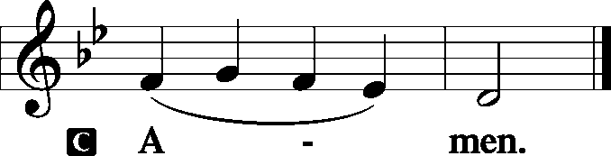

THE BIBLE READINGS
God speaks to us.
The Old Testament Reading:
Isaiah 55:6-9 Seek the LORD while He may be found, Call upon Him while He is near. 7 Let the wicked forsake his way, And the unrighteous man his thoughts; Let him return to the LORD, And He will have mercy on him; And to our God, For He will abundantly pardon. 8 "For My thoughts are not your thoughts, Nor are your ways My ways," says the LORD. 9 "For as the heavens are higher than the earth, So are My ways higher than your ways, And My thoughts than your thoughts.

PASTOR Here ends the Old Testament reading. We continue with the responsive reading of:
THE GRADUAL
The Gradual is a “Bridge of praise” that links the Old Testament with the New Testament.
P: Blessed is the nation whose God is the Lord:
C: And the people whom He has chosen for His own inheritance.
P: By the Word of the Lord were the heavens made:
C: And all the host of the them by the breath of His mouth.
Hallelujah! Hallelujah!
P: The right hand of the Lord is exalted:
C: The right hand of the Lord does valiantly. Hallelujah!

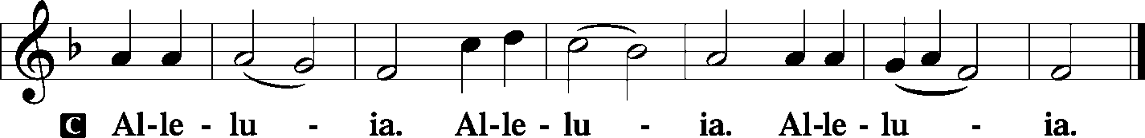

PASTOR The Epistle Reading comes from Philippians chapter 1, beginning there in the 1st verse.
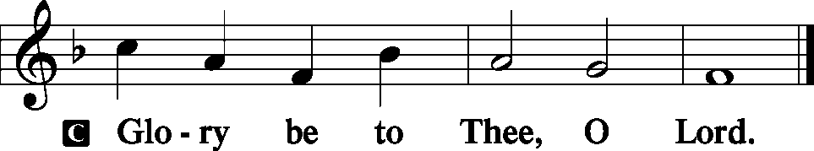

The Epistle Reading:
Philippians 1:1-5,19-27 Paul and Timothy, bondservants of Jesus Christ, To all the saints in Christ Jesus who are in Philippi, with the bishops and deacons: 2 Grace to you and peace from God our Father and the Lord Jesus Christ. 3 I thank my God upon every remembrance of you, 4 always in every prayer of mine making request for you all with joy, 5 for your fellowship in the gospel from the first day until now, 19 For I know that this will turn out for my deliverance through your prayer and the supply of the Spirit of Jesus Christ, 20 according to my earnest expectation and hope that in nothing I shall be ashamed, but with all boldness, as always, so now also Christ will be magnified in my body, whether by life or by death. 21 For to me, to live is Christ, and to die is gain. 22 But if I live on in the flesh, this will mean fruit from my labor; yet what I shall choose I cannot tell. 23 For I am hard pressed between the two, having a desire to depart and be with Christ, which is far better. 24 Nevertheless to remain in the flesh is more needful for you. 25 And being confident of this, I know that I shall remain and continue with you all for your progress and joy of faith, 26 that your rejoicing for me may be more abundant in Jesus Christ by my coming to you again. 27 Only let your conduct be worthy of the gospel of Christ, so that whether I come and see you or am absent, I may hear of your affairs, that you stand fast in one spirit, with one mind striving together for the faith of the gospel.
PASTOR Here ends the Epistle Reading.
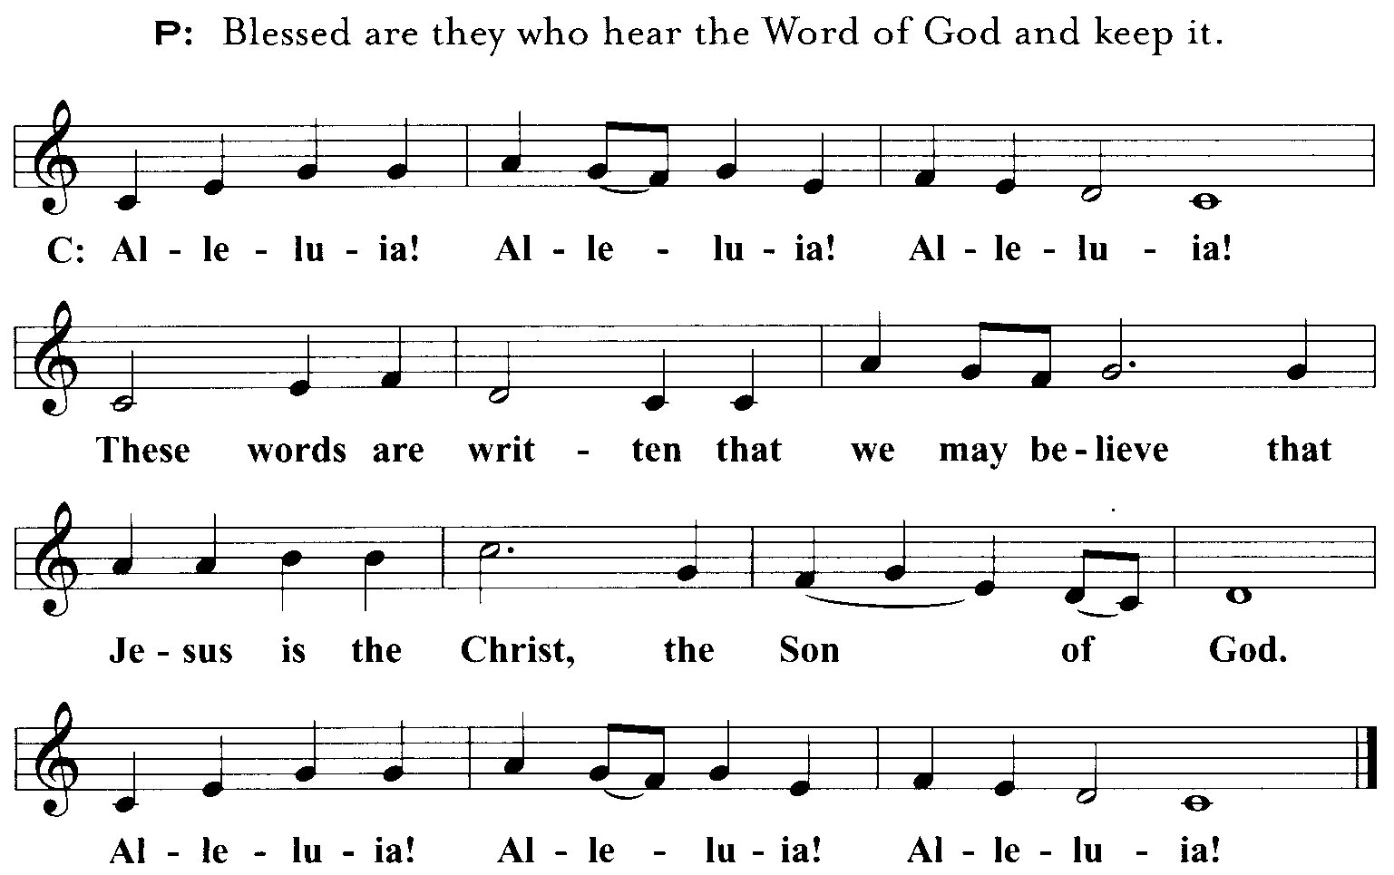

THE NICENE CREED
We boldly confess what we believe. (Hymnal, page 22)
I believe in one God, the Father Almighty, Maker of heaven and earth and of all things visible and invisible.
And in one Lord Jesus Christ, the only-begotten Son of God, begotten of His Father before all worlds, God of God, Light of Light, Very God of Very God, Begotten not made, Being of one substance with the Father, By whom all things were made; Who for us men and for our salvation came down from heaven And was incarnate by the Holy Ghost of the Virgin Mary And was made man; And was crucified also for us under Pontius Pilate. He suffered and was buried; And the third day He rose again according to the Scriptures; And ascended into heaven, And sitteth on the right hand of the Father; And He shall come again with glory to judge both the quick and the dead; Whose kingdom shall have no end.
And I believe in the Holy Ghost, The Lord and Giver of Life, Who proceedeth from the Father and the Son, Who with the Father and the Son together is worshiped and glorified, Who spake by the Prophets. And I believe one holy Christian and Apostolic Church. I acknowledge one Baptism for the remission of sins, And I look for the resurrection of the dead, And the life of the world to come. Amen.

Hymn 492

THE SERMON
Matthew 20:1-16 "For the kingdom of heaven is like a landowner who went out early in the morning to hire laborers for his vineyard. 2 "Now when he had agreed with the laborers for a denarius a day, he sent them into his vineyard. 3 "And he went out about the third hour and saw others standing idle in the marketplace, 4 "and said to them, 'You also go into the vineyard, and whatever is right I will give you.' So they went. 5 "Again he went out about the sixth and the ninth hour, and did likewise. 6 "And about the eleventh hour he went out and found others standing idle, and said to them, 'Why have you been standing here idle all day?' 7 "They said to him, 'Because no one hired us.' He said to them, 'You also go into the vineyard, and whatever is right you will receive.' 8 "So when evening had come, the owner of the vineyard said to his steward, 'Call the laborers and give them their wages, beginning with the last to the first.' 9 "And when those came who were hired about the eleventh hour, they each received a denarius. 10 "But when the first came, they supposed that they would receive more; and they likewise received each a denarius. 11 "And when they had received it, they complained against the landowner, 12 "saying, 'These last men have worked only one hour, and you made them equal to us who have borne the burden and the heat of the day.' 13 "But he answered one of them and said, 'Friend, I am doing you no wrong. Did you not agree with me for a denarius? 14 'Take what is yours and go your way. I wish to give to this last man the same as to you. 15 'Is it not lawful for me to do what I wish with my own things? Or is your eye evil because I am good?' 16 "So the last will be first, and the first last. For many are called, but few chosen."

Theme: "THE STRANGE LABOR LAWS OF GOD'S VINEYARD"
I. Bitterly disappointing to some
II. Overwhelmingly gratifying to others
Sermon Notes

THE OFFERTORY
In this prayer we OFFER God our hearts, asking Him for that best of all gifts, the Holy Spirit.
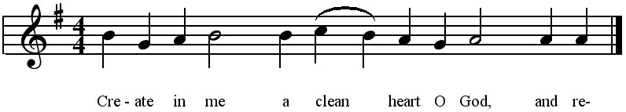
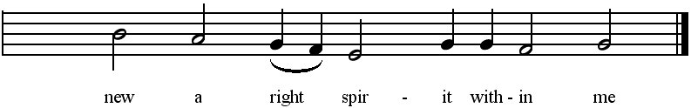
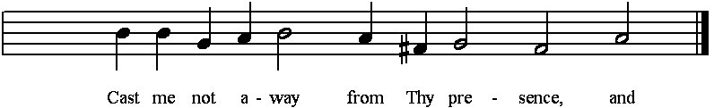
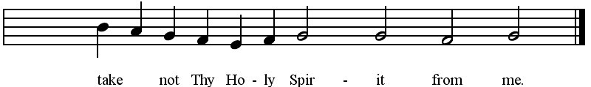
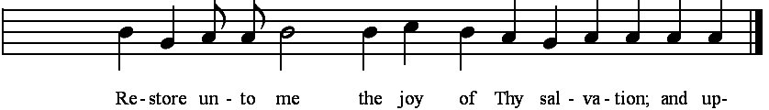
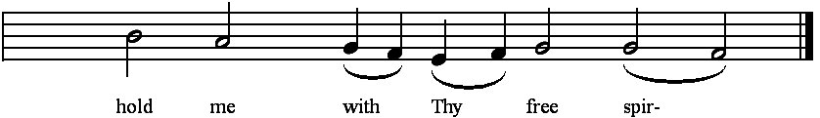


THE OFFERING OF THANKFUL HEARTS
In tangible evidence of our gratitude, we offer the Lord the gift of our money, remembering that He has first given to us that we might have to give to Him. While the ushers present our
offerings at the Lord’s Altar, we stand and sing the offering hymn 441:1-2:
We give Thee but Thine own, Whate'er the gift may be;
All that we have is Thine alone, A trust, O Lord, from Thee.
May we Thy bounties thus As stewards true receive
And gladly, as Thou blessest us, To Thee our first-fruits give!

PRAYERS - (Pastor)
THE LORD’S PRAYER - (All)
Our Father Who art in heaven, hallowed be Thy name. Thy kingdom come. Thy will be done on earth as it is in heaven. Give us this day our daily bread, and forgive us our trespasses as we forgive those who trespass against us. And lead us not into temptation, but deliver us from evil. For Thine is the kingdom and the power and the glory forever and ever, Amen.
Congregation sings Hymn 307

The Communion Liturgy

THE PREFACE/ PROPER PREFACE
Now we approach the second high point of the liturgy, the Sacrament, in which the Lord
comes to bless us with His very body and blood. We move toward the Sacrament
with prayers of thanksgiving and songs of adoration. Please stand.


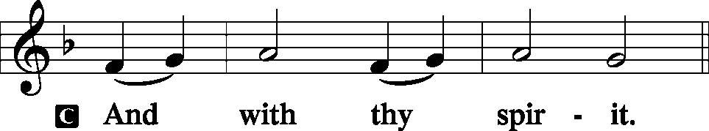

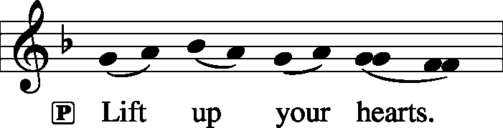
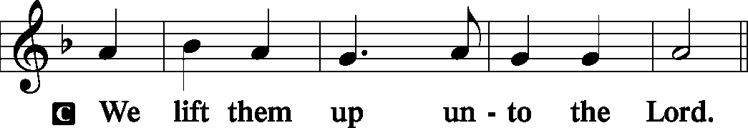

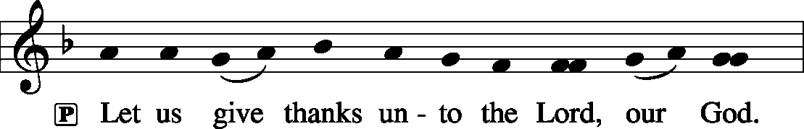
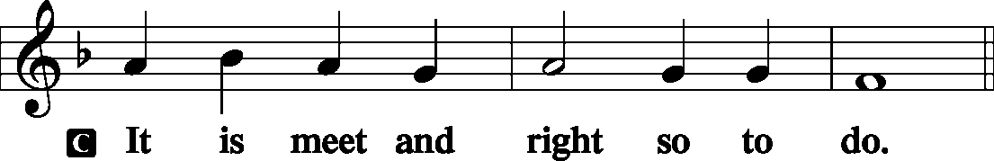

PASTOR: Thanks and praise be to You, our Father, almighty Creator, merciful Lord, God of promise and fulfillment, for You kept Your promises through the death and resurrection of Jesus Christ, Your Son. By His death He has destroyed death and by His resurrection has restored to us everlasting life. And so, with the church on earth and the hosts of heaven, we praise Your name and join their unending hymn.

THE SANCTUS
Latin: “Holy.” We join our voices to the angels who sing, "Holy, Holy, Holy" around His throne”
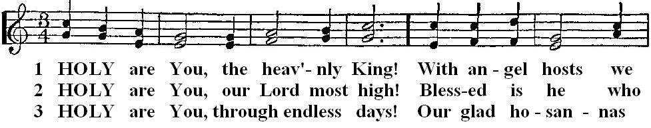
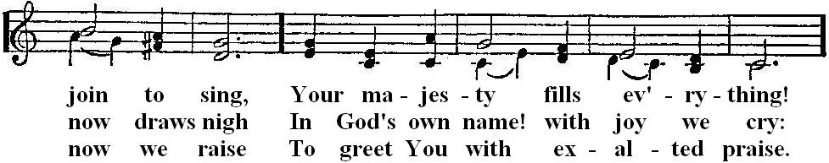
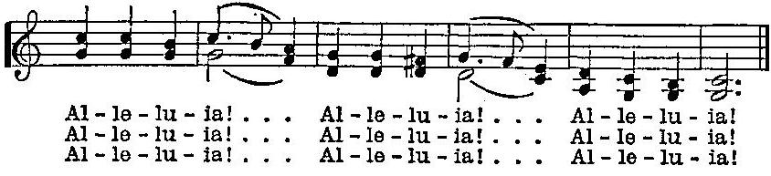

THE WORDS OF INSTITUTION
(The words spoken by Jesus the night He instituted the Lord’s Supper by which our Lord assured to His Church the real presence of His sacramental body and blood for all time

PASTOR: Our Lord Jesus Christ, the same night in which He was betrayed, took bread; and when He had given thanks, He broke it and gave it to His disciples, saying, "Take eat; this is My body, which is given for you. Do this in remembrance of Me."
In the same way He took the cup, after supper, gave thanks, and gave it to them, saying, "Drink of it, all of you. This cup is the New Testament in My blood, which is shed for you for the forgiveness of sins. Do this, whenever you drink it, in remembrance of Me."
The peace of the Lord be with you always.

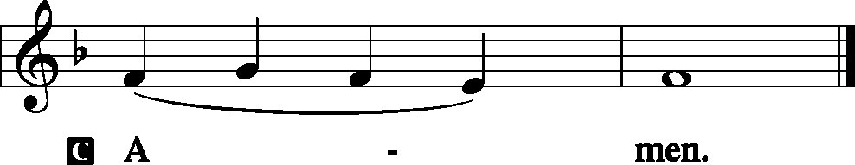

THE AGNUS DEI
Latin: “Lamb of God.” As we approach the Table of Forgiveness, we want to
think only of that Lamb of God who was sacrificed for us on Calvary's cross.
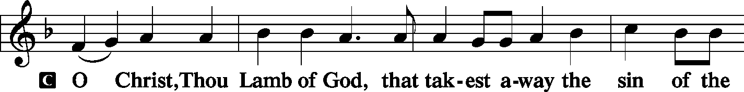
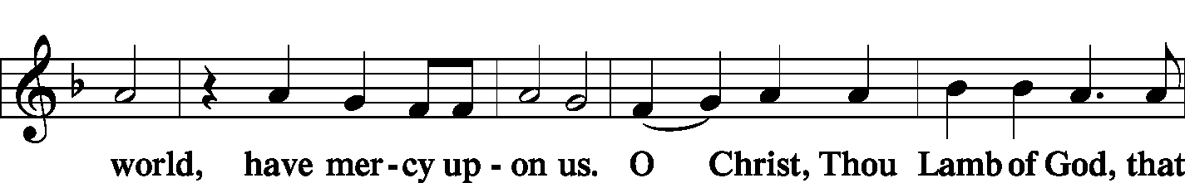
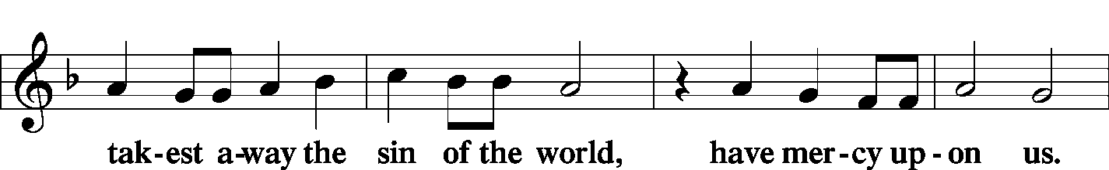
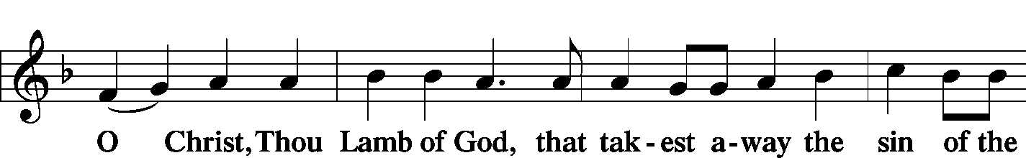
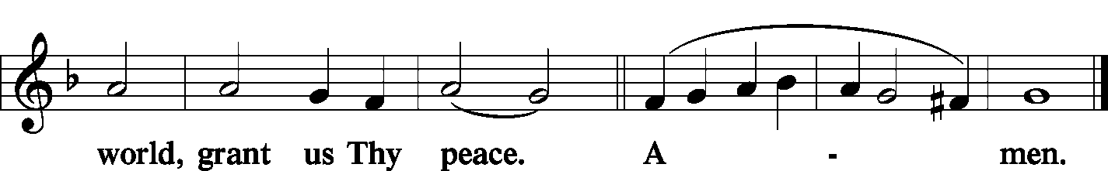

The Distribution of the Sacrament (congregation is seated)

COMMUNION TODAY IS FOR MEMBERS ONLY
A Note To Our Visitors: According to God’s Word, partaking of the Lord’s Supper with other Christians implies a oneness and unity of faith and belief. God wants us to be like-minded in our beliefs before we enter into fellowship such as Holy Communion. (1 Corinthians 1:10 and 1 Corinthians 10:17). Therefore, if you have not publicly declared your agreement with the teachings of this Christian congregation through formal membership, we ask that you please speak with our pastor before coming to the Lord’s Supper. In practicing close communion, we are not entering into a judgment concerning the faith of individual members of other churches. We rejoice over all those who have saving faith in Jesus Christ. Fellowship at this altar is established by sharing in a common confession of faith, anchored in the Gospel of Jesus Christ. We sincerely want all people to receive the Lord’s Body and Blood with us, but we want them to receive this sacrament in a way that pleases our Lord. As a steward of God’s mysteries, our pastor stands ready to assist you in preparing to come to the Lord’s Supper with us by teaching and reviewing God’s Word with you. Thank You.
A Note To Our Members: SHOULD YOU COME TO THE LORD'S SUPPER?
*** If you feel your faith is weak, you need the Lord's Supper. In it Jesus gives you his body and blood which were given into death for your sins. He wants to strengthen your faith. So come, eat and drink and listen to the words your pastor says to you in the name of Jesus, and believe them with all your heart.
*** When you know you've sinned and you feel unworthy. You say you aren't worthy because you aren't good enough. No one else is good enough either. But God doesn't ask whether you are good enough. He only asks, `Are you sorry for your sins? Do you believe Jesus forgives?' He invites you to come and receive forgiveness through Christ, who shed his blood for you. He makes you sure that forgiveness is yours by giving you Jesus' body and blood to eat and to drink. You believe that, don't you?
*** But if you are refusing to give up a particular sin even though you know that God's word forbids it, you are despising God's Word. You are telling God, `I don't care what you say. I'll do what I want.' Until you repent of your sin, God warns you against abusing this gift. To come to the Lord's Supper will only add to your sin rather than take it away.
THREE GOOD QUESTIONS TO ASK YOURSELF BEFOREHAND
1) Am I sorry for my sins?
2)Do I believe in Christ for forgiveness?
3)Am I willing, after receiving forgiveness, to amend my sinful life?
MARTIN LUTHER: "He is truly worthy and well prepared who has faith in these words, `Given and shed for you for the remission of sins.'"

THE NUNC DIMITTIS
Latin: “Now Dismiss.” Simeon’s words after seeing the Christ Child. (Luke 2:29-32)
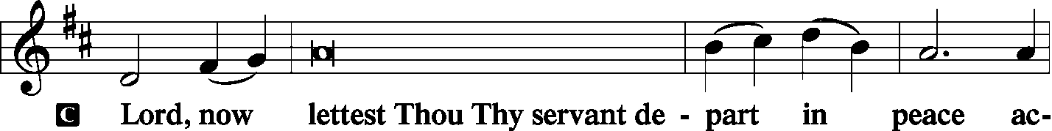
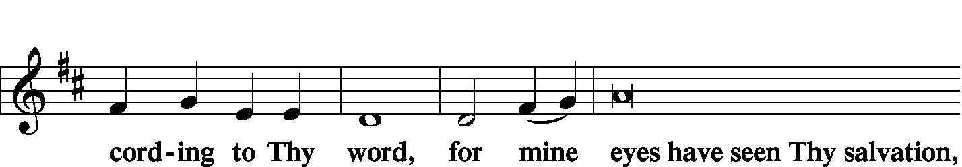
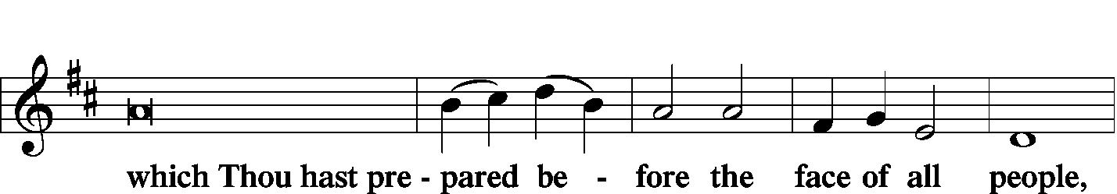
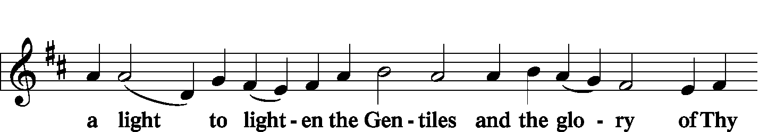
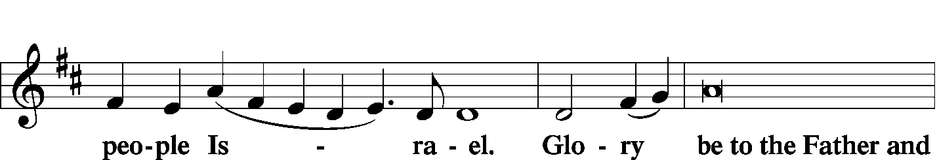
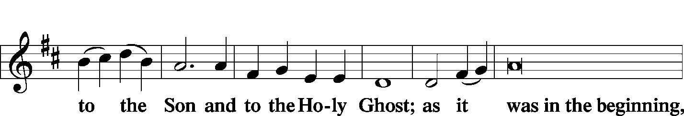
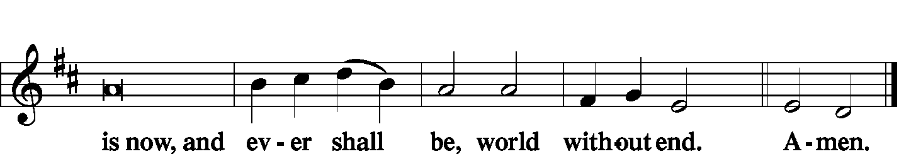

PASTOR: Oh, give thanks unto the Lord, for He is good.
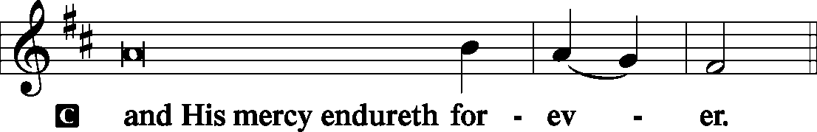

PASTOR: We give thanks to You, almighty God, that You have refreshed us through this salutary gift, and we beseech You that of Your mercy You would strengthen us through the same in faith toward You and fervent love toward one another; through Jesus Christ, Your Son, our Lord, who lives and reigns with You and the Holy Spirit, one God, forever and ever.
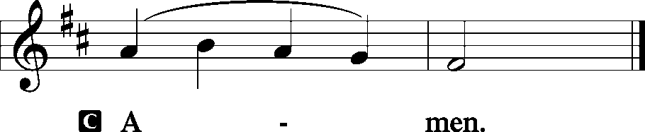

THE BENEDICTION

The blessing given by God for His people (Numbers 6:24-26)
PASTOR:
The Lord bless you and keep you.
The Lord make His face shine upon you and be gracious unto you.
The Lord lift up His countenance upon you and give you peace.
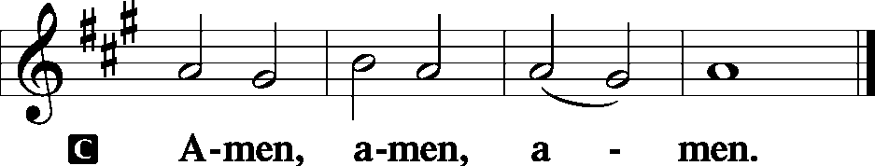

Closing Hymn 46
A n n o u n c e m e n t s
“If the LORD wills, we will do this or that.” James 4:15

WELCOME EVERYONE! Especially any visitors who may be with us. We are glad you are here and invite you to join us again soon in our worship of the One true God; Father, Son and Holy Spirit. If you are looking for a church home, we hope you’ve found it with us. If you’d like to become a member, we offer a free “Information Course” in which the Pastor will meet with you at your convenience to study and discuss the Bible’s teachings. Just ask!

NO TUESDAY BIBLE STUDY THIS WEEK – we’ll start again next Tuesday.

NOTE FROM THE ST. JOHN’S TREASURER
Many people purchase from Amazon online. It is now possible to have ½% of your purchase value go directly to St Johns bank account. This is at no cost to the consumer, so please use this when you purchase from Amazon. Here is how to use it… Logon to https://smile.amazon.com/ (do not use WWW in the address line). Go to (or pick your own charitable organization) and type 23-7112865 . Then SEARCH. Then SELECT. From then when you log on to https://smile.amazon.com/ you will see the following message at the top of your shopping screen Supporting: St. John's Evangelical Lutheran Church. If you logon to Amazon any other way the donation to the church will not take place.

CLC COORDINATING COUNCIL meets this week at Immanuel Lutheran College in Eau Claire, WI. The primary function of the CC is to coordinate the work of the five boards of the CLC (Doctrine, Regents, Missions, Trustees, Education & Publications). They meet twice a year in the Fall and the Spring. CC consists of the CLC President & Secretary, the President of ILC, the Chairman of the Board of Doctrine, and one called servant and one layman from each of the other boards. These 13 men propose the annual budget to be presented to Convention. In off convention years, the CC sets the budget. They also function as the Board of Directors for the CLC. This body remains advisory except in areas specified by the Convention or Constitution. Pastor Naumann serves as Chairman of the Board of Education and Publications (BOEP), and will be attending.

ST. JOHN’S REMINDERS:
Church Cleaning: There is a list for you to sign if you are able to serve your LORD by cleaning the church.
Altar Flowers: There is a list for those who wish to bring flowers for the altar on any given Sunday.
Pre-service Goodies: If you are able to bring goodies of some kind for people to eat while they are visiting before or after service, please sign on the sheet in Kitchen.

NEXT SUNDAY’S SERVICE If you’d like to read them ahead of time at home, the Bible readings for next week are:
Ezekiel 18:1-4,25-32 – God has no pleasure in the death of the unrepentant
Philippians 2:1-5, 6-11 – Imitate Christ’s self-sacrificing humility
Matthew 21:28-32 – God rejoices in the repentance of a sinner (sermon)

CLC NEWS <> The Rev. Nathan Pfeiffer, pastor of Trinity Lutheran, Spokane, WA, has the call to Faith Lutheran, Markesan WI. <> Zion Lutheran, Lawrenceville GA, has called the Rev. Michael Roehl, pastor of St. Paul Lutheran, Bismarck ND. <> The Rev. Steven Karp, pastor of St. Stephen Lutheran, Hayward CA, has announced his retirement. He will continue serving St. Stephen for a time. <> Rock of Ages Lutheran, Grand Rapids MI, has called the Rev. Paul Tiefel, pastor of Messiah Lutheran, Eau Claire WI.

WEEKLY MEMORY VERSE
When I said, "My foot is slipping," Your love, O LORD, supported me. When anxiety was great within me, Your consolation brought joy to my soul. Psalms 94:18-19

The Old Testament Reading:
From little on we learn that we don’t always get our way. And it’s a good thing. In these verses, the LORD offers us “His Way” and encourages us to return to Him and his abundant mercy and pardon. We read…
Isaiah 55:6-9 Seek the LORD while He may be found, Call upon Him while He is near. 7 Let the wicked forsake his way, And the unrighteous man his thoughts; Let him return to the LORD, And He will have mercy on him; And to our God, For He will abundantly pardon. 8 "For My thoughts are not your thoughts, Nor are your ways My ways," says the LORD. 9 "For as the heavens are higher than the earth, So are My ways higher than your ways, And My thoughts than your thoughts.

THE GRADUAL
P: Blessed is the nation whose God is the Lord:
C: And the people whom He has chosen for His own inheritance.
P: By the Word of the Lord were the heavens made:
C: And all the host of the them by the breath of His mouth.
Hallelujah! Hallelujah!
P: The right hand of the Lord is exalted:
C: The right hand of the Lord does valiantly. Hallelujah!

The Epistle Reading:
Sometimes believers wonder why they’re still here. Sometimes believers wonder why one of they’re loved ones was taken by the LORD to heaven. The answer is in these verses. Whether we live or die, by faith we exalt, praise, and glorify our Savior Jesus. We read…
Philippians 1:5,19-27 Paul and Timothy, bondservants of Jesus Christ, To all the saints in Christ Jesus who are in Philippi, with the bishops and deacons: 2 Grace to you and peace from God our Father and the Lord Jesus Christ. 3 I thank my God upon every remembrance of you, 4 always in every prayer of mine making request for you all with joy, 5 for your fellowship in the gospel from the first day until now, 19 For I know that this will turn out for my deliverance through your prayer and the supply of the Spirit of Jesus Christ, 20 according to my earnest expectation and hope that in nothing I shall be ashamed, but with all boldness, as always, so now also Christ will be magnified in my body, whether by life or by death. 21 For to me, to live is Christ, and to die is gain. 22 But if I live on in the flesh, this will mean fruit from my labor; yet what I shall choose I cannot tell. 23 For I am hard pressed between the two, having a desire to depart and be with Christ, which is far better. 24 Nevertheless to remain in the flesh is more needful for you. 25 And being confident of this, I know that I shall remain and continue with you all for your progress and joy of faith, 26 that your rejoicing for me may be more abundant in Jesus Christ by my coming to you again. 27 Only let your conduct be worthy of the gospel of Christ, so that whether I come and see you or am absent, I may hear of your affairs, that you stand fast in one spirit, with one mind striving together for the faith of the gospel.

PASTOR Here ends the Epistle Reading. Blessed...

